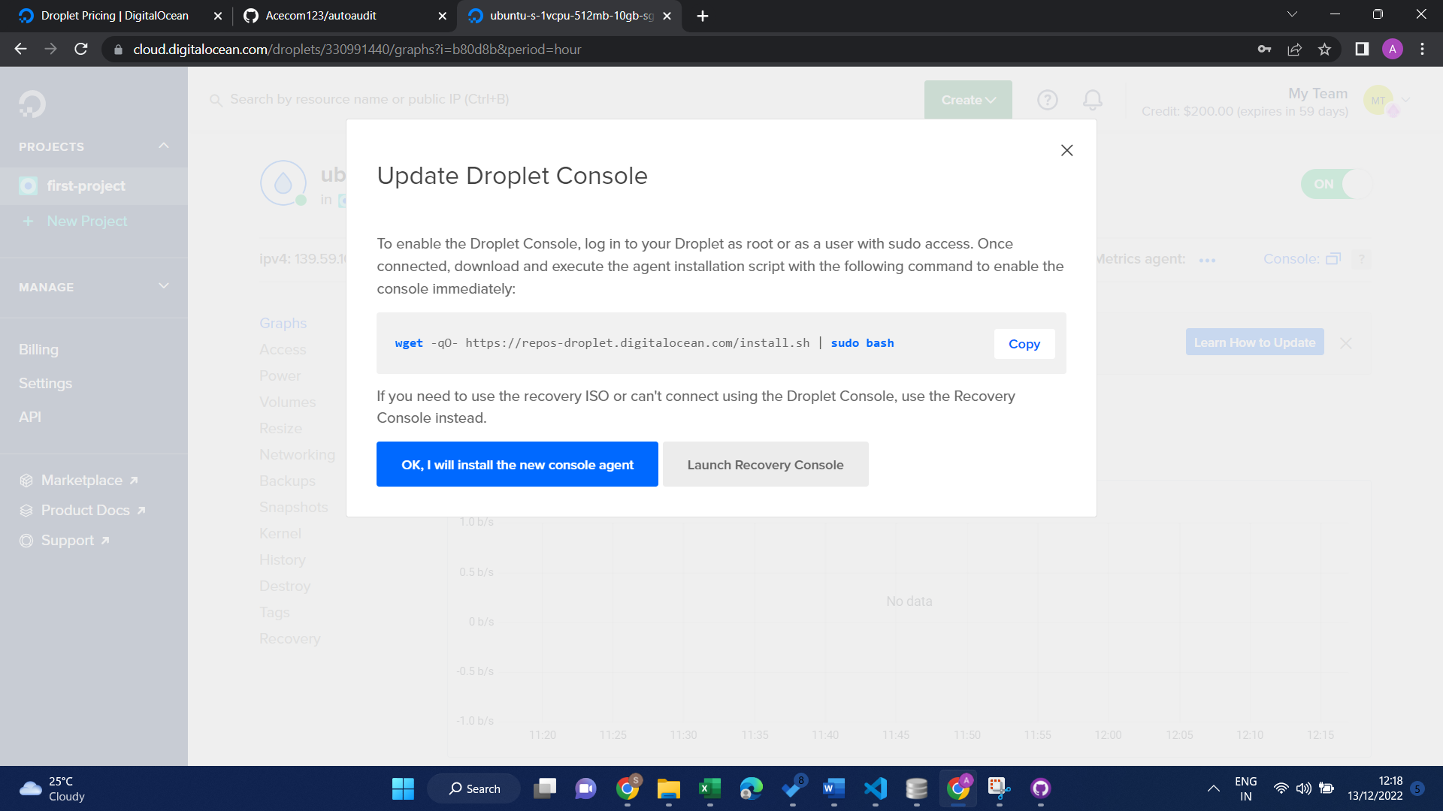

wget -qO- https://repos-droplet.digitalocean.com/install.sh | sudo bash

change directory= cd “autoaudit”

Docker

<https://www.digitalocean.com/community/tutorials/how-to-install-and-use-docker-on-ubuntu-22-04>

1. sudo apt update

pip install –upgrade pip

follow

<https://docs.streamlit.io/knowledge-base/tutorials/deploy/docker#install-docker-engine>

OR second way

Check python is installed?

Cd “autoadit”

Load requirements.txt

Run python app

# DROPLET Process

# Droplet

[Sdjog7@gmail.com](mailto:Sdjog7@gmail.com)

shree@7178

droplet password- autoAudit@123A

on root- following commands

* sudo apt-get update
* sudo apt-get upgrade
* sudo apt-get install python3 python3-pip python3-venv
* mkdir autoaudit
* cd autoaudit
* create virtual env- python3 -m venv venv
* activate venv- source venv/bin/activate
* copy all files autoaudit folder- project directory
* cd project
* pip install –r requirements.txt OR pip3
* streamlit run Home.py
* To keep running use pm2
* PM2

# Process manager

## On root install npm

* apt install npm
* then-npm install -g pm2
* now go to app folder-
* cd “autoaudit”/project
* create file- **run-app.py**
* this will contain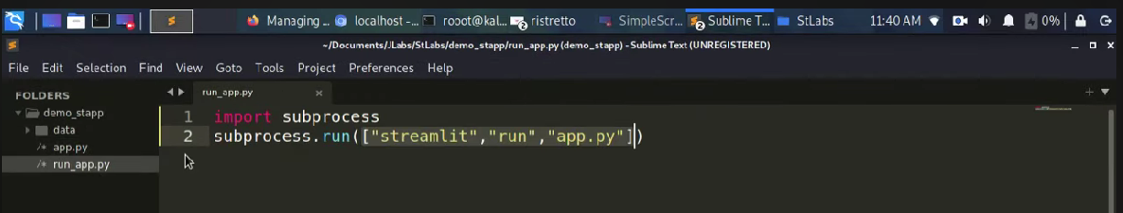
* instead of app.py- use-our file- Home.py
* Now Run stramlit app by following command-
* pm2 start run-app.py --interpreter python3
* streamlit
* Other commands-
* pm2 –help
* pm2 status
* to run app manually-
* 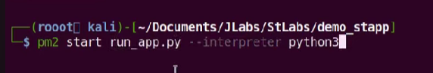
* Pm2 logs
* Pm2 ls- list process
* Pm2 stop **run_app**

ubuntu commands- <https://linuxhint.com/basic-25-ubuntu-commands/>

# file zilla

host- ip address- 159.65.153.207

username- root

password- password for droplet- autoAudit@123A

port- 22 (default)